**Agile:**

It is an approach that involves breaking processes and projects down into incremental pieces or phases. So rather than trying to do everything in one go (the ‘waterfall approach’), agile teams divide their tasks into discrete modules that they test and perfect individually before continuing.

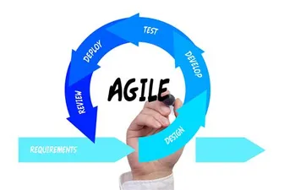

Advantages:

* More flexible to changes. Adapting to changes faster than other approaches.
* Better communication as the project team works closely with the customers.

Disadvantages:

* It is hard to pin down specific deadlines and costs.
* Neglect of paperwork due to changing from one stage to another prematurely or unplanned so the paper work wasn’t completed.

My understanding:

Can always go back from one stage to another due to planning everything individually so nothing gets in the way of the other.

**Rad:**

RAD Model or Rapid Application Development model is a software development process based on prototyping without any specific planning. In the RAD model, there is less attention paid to the planning and more priority is given to the development tasks. It targets developing software in a short span of time.

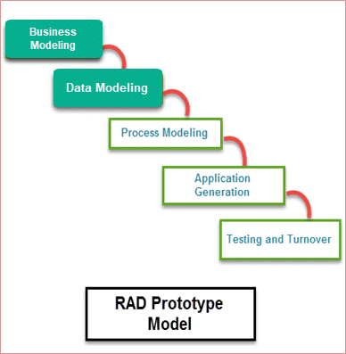

Advantages:

* Flexible and adaptable to changes
* It is useful when you must reduce the overall project risk

Disadvantages:

* It can’t be used for smaller projects
* When technical risk is high, it is not suitable

My understanding:

It does little planning and gets straight to work. They focus more on the development stage trying to finish it faster

**Spiral:**

The Spiral model is built around a four-phase development cycle. The development progresses in an iterative way, as it effectively loops through the various stages of the development cycle – like a spiral. There can be any number of loops, depending on the size of the project.

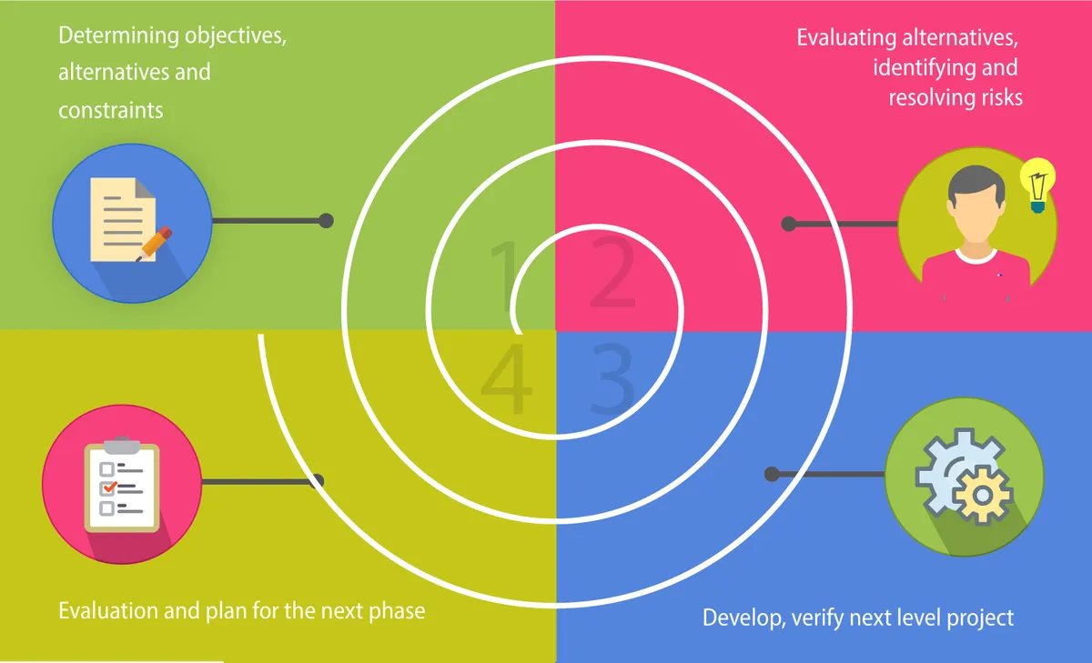

Advantages:

* Highly flexible model
* Fast and cost-effective development
* Well-suited for large scale projects and mission-critical developments

Disadvantages:

* Can be expensive to implement – especially if spirals continue infinitely
* Success may depend greatly on the risk analysis
* Not an ideal fit for smaller or low-risk projects

My understanding:

They can keep doing the 4 stages repeatedly until they are happy with how the application is.

**Waterfall:**

We often describe Waterfall as a ‘linear-sequential lifecycle model.’ This means that it follows a simple structure of phases where the results of each phase cascade down to the next level of development. In other words, we are not so much looking at one big Niagara Falls, but a series of cascading waterfalls – each with their own little pool of activities.

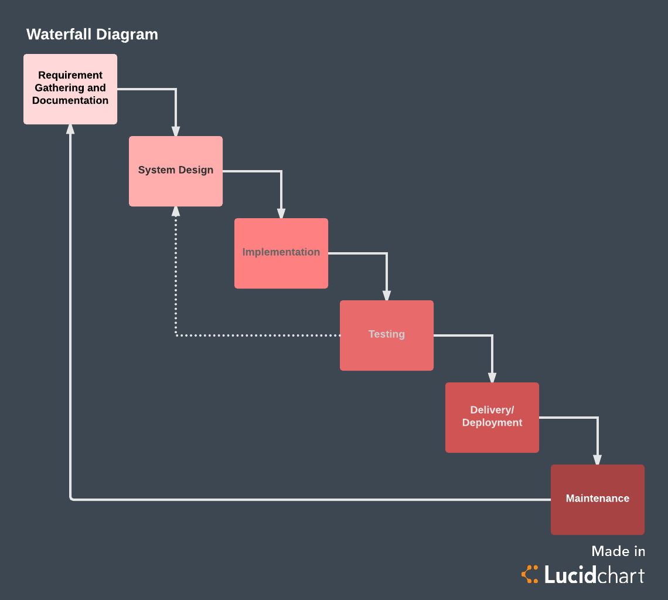

Advantages:

* Everyone gets up to speed quickly
* No financial surprises
* Timescales are kept
* The outcome is crystal clear

Disadvantages:

* Needs can be difficult to define
* Potential lack of flexibility
* Longer delivery time

My understanding:

Going step by step and not going off track even if there are minor changes. This is a straight-forward plan that you will stick to until the end.